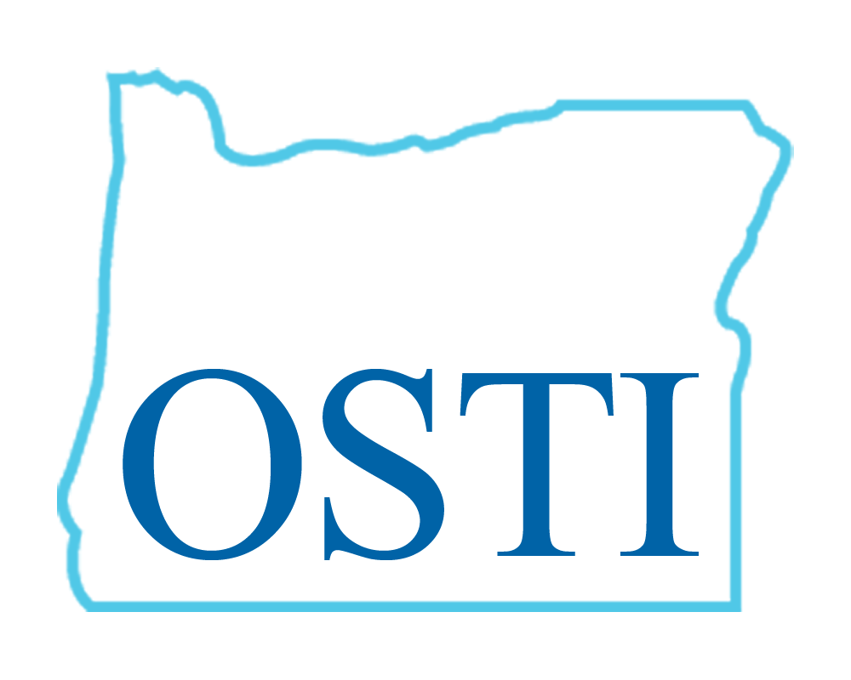
CALL FOR PAPERS

OREGON SOCIETY OF TRANSLATORS AND INTERPRETERS
2019 ANNUAL CONFERENCE
September 14th-15th

Bridges Across Borders

The Oregon Society of Translators and Interpreters is a professional organization where independent translators and interpreters of all languages and specialties connect and grow.

We are seeking presentations that will provide a forum for professional development through educational workshops and activities that facilitate and promote ongoing learning. We encourage topics of interest to translators, court and medical interpreters. The presentations should be engaging and diverse in nature, to keep with the theme of this year’s conference.

This is a great opportunity to visit Portland, the City of Roses or also known as the City of Bridges. Explore its many natural wonders like Mt. Hood, the Oregon Coast, Multnomah Falls, and the Gorge. Experience the culinary scene from food carts to innovative restaurants. Take a tour of our local breweries and wineries.

Please submit your proposals no later than May 31st to conference@ostiweb.org.

www.ostiweb.org

